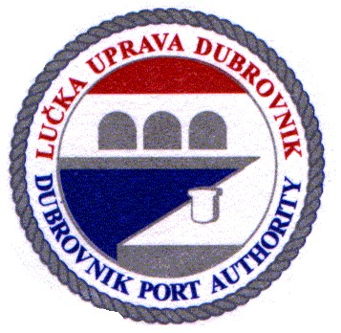

PLAN FOR RECEPTION AND HANDLING OF WASTE
IN THE AREA MANAGED BY THE PORT AUTHORITY OF DUBROVNIK

May 2022

Contents

1 INTRODUCTION (GENERAL PROVISIONS) 4
2 GENERAL INFORMATION 6
3 GENERAL TERMS (DEFINITIONS) 6
3.1 DEFINITIONS OF WASTE-RELATED TERMS – REGULATION 8
3.2 DEFINITIONS OF CONCEPTS RELATED TO LAND- BASED WASTE 9
4 MANAGEMENT OF SHIP-GENERATED WASTE 10
5 EXEMPTION FROM COMPLIANCE WITH THE PLAN 10
6 ASSESSMENT OF PORT FACILITIES REQUIREMENTS IN ACCORDANCE WITH MARPOL CONVENTION 11
7 PORT WASTE RECEPTION FACILITIES – DESCRIPTION, TYPES AND CAPACITY 17
8 ENVIRONMENTAL MANAGEMENT SYSTEM 22
9 SELF-GENERATED OPERATIONAL WASTE 23
10 PROCEDURES FOR RECEPTION AND COLLECTION BY TYPES OF SHIP-GENERATED WASTE 23
10.1 Liquid oily waste (Regulation 38 of Annex I of consolidated MARPOL 73/78 Convention) 23
10.2 Waste collection vehicle 24
10.3 Noxious waste (Annex I, II, III, IV, V i VI MARPOL 73/78 Convention) 24
10.4 Sewage (Annex IV of MARPOL 73/78 Convention) 24
10.5 Plastics (Annex V of MARPOL 73/78 Convention - Category A) 24
10.6 Food waste (Annex V of MARPOL 73/78 Convention - Category B) 25
10.7 Domestic waste (Annex V of MARPOL 73/78 Convention - Category C) 25
10.8 Cooking oil (Annex of V MARPOL 73/78 Convention - Category D) 25
10.9 Incinerator ashes (Annex V of MARPOL 73/78 Convention - Category E) 25
10.10 Operational waste (Annex V of MARPOL 73/78 Convention - Category F) 25
10.11 Animal by-products not intended for human consumption (animal carcasses) (Annex V of MARPOL 73/78 Convention - Category G) 25
10.13. Electric and electronic waste ( Annex V of MARPOL 73/78 Convention - Category l) 26
11 ADVANCE NOTIFICATION OF WASTE DELIVERY 26
11.1. WASTE COLLECTION ARRANGEMENTS BY CONCESSIONAIRE 28
11.2 COLLECTION, TEMPORARY STORAGE, TREATMENT AND WASTE DISPOSAL 28
11.3 WASTE DELIVERY RECEIPT 29
11.4 VESSELS (YACHTS) OF GROSS TONNAGE OF OR OVER 300 OR MORE THAN 45 M IN LENGTH, FOREIGN-OWNED, OWNED BY A NATURAL AND LEGAL ENTITY FROM REPUBLIC OF CROATIA 29
11.5 EXEMPTION FROM OBLIGATION TO PROVIDE ADVANCE NOTIFICATION 29
12 AREA NOT SUBJECT TO WASTE MANAGEMENT ACT (OFFICIAL GAZETTE 84/2021) 30
13 PRESENTATION AND CALCULATION OF THE ACTUAL COLLECTION COSTS FOR WASTE DELIVERED BY VESSELS 31
14 INSTRUCTIONS IN WRITING 31
15 USERS' COMPLAINTS 31
16 DESCRIPTION OF TARIFF SYSTEM 32
17 OVERVIEW AND CALCULATION OF ACTUAL COLLECTION COSTS 33
17.1.METHOD OF DETERMINING TARIFFS AND EXCESS WASTE NOT COVERED BY TARIFFS 33
17.2. DIRECT COSTS 34
18 DETERMINING THE PERSONS OR A PERSON RESPONSIBLE FOR IMPLEMENTATION OF THE PLAN 34
19 FINAL PROVISIONS 34
20 LIST OF ANNEXES 35

Pursuant to Articles 56, 56 a and 58 of Maritime Code (“Official Gazette“, no. 181/04, 76/07, 146/08, 61/11, 56/13, 26/15, 17/19), Article 3 (1) (7) of Regulation on conditions to be complied with by all Ports (“Official Gazette“, br. 110/04), Art. 61. Paragraph 1 of the Regulation on conditions and method of maintaining order in ports and on other parts of the internal sea waters and the territorial sea of the Republic of Croatia ( “Official Gazette“, 72/2021), Directive (EU) 2019/883 of the European Parliament and Council of 17 April 2019 on reception facilities in ports for waste disposal from ships of Directive 2010/65 (EU) of the European Parliament and Council of 20 October 2010 on reporting on ships' arrivals and /or departures from ports of the Member States, MARPOL Convention 73/78 as amended, and Waste Management Act (“Official Gazette“, 84/2021) and Article 18 Paragraph 18, Item 10 of Statute of Port Authority, Governing Council of Dubrovnik Port Authority, at their 164th session held on 27 May 2022, brought the following:

PLAN FOR RECEPTION AND HANDLING OF WASTE
IN THE AREA MANAGED BY THE PORT AUTHORITY OF DUBROVNIK

1 INTRODUCTION (GENERAL PROVISIONS)
Plan for reception and handling of waste (hereinafter: 'the Plan') in the area managed by Dubrovnik Port Authority (hereinafter: 'Tariff') prescribes reception and handling of ship-generated waste in the area under management of Port Authority, and is to be applied to all vessels, irrespective of their flags, which berth and stay in the Tariff, “excepting war and public ships“.
The area under management of Port Authority covers land and maritime area as stated in Act on Establishment of Dubrovnik Port Authority (NG 19/97; 21/02; 158/03; 113/13; 108/15).
The Plan regulates:
1 reception and handling of ship-generated waste;
2 ways and procedures of managing ship-generated accumulated waste and cargo residues from vessels entering the Tariff;
3 protecting the marine environment from discharges or dumping of ship waste;
4 protecting the land area of the Port from pollution.
All natural persons and legal entities using the port facilities shall observe and comply with the provisions of the Maritime Code of the Republic of Croatia (NG 118/04, 76/07, 146/08, 61/11, 56/13, 26/15 i 17/19), as well as Port Regulation on the maintenance of order of port in the Tariff.
The plan was drawn up for land and maritime domains of Tariff In accordance with Regulation on conditions and method of maintaining order in ports and in other parts of the internal sea waters and territorial sea of the Republic of Croatia (NG 72/2021) (hereinafter: 'the Regulation') with prior consultations carried out with port users and representatives of port users:
1 Dubrovnik Port Authority,
2 Port of Dubrovnik d.d. (Inc.)
3 Platanus d.o.o. (Ltd.)
4 Jadrolinija d.d. (Inc.)
5 TP line d.o.o. (ltd)
6 Cian d.o.o. (Ltd)
Dubrovnik Port Authority shall conduct continuous consultations with port users, local ports, competent local authorities, specialized collectors, organisations implementing extended producer responsibility obligations and representatives of civil society, liner services ship operators, ship operators who regularly use the port under the Dubrovnik Port Authority, as well as other persons and bodies.
Notifications and invitations to consultations shall be made available to the public via the official website.
The deadline for submission of observations by the public concerned is within 15 days of publication of the call on official website of P ort Authority www.portdubrovnik.hr
The final consultations date should be 31 January at the latest for the past year. Additional consultations shall be held before each revision or update of the Plan.

2 GENERAL INFORMATION
According to classification under the formal and legal determining of the port system of the Republic of Croatia, the Dubrovnik port has been categorized as a passenger port open to public traffic, it is one of six ports of international economic interest to the Republic of Croatia.
The reference years as an indicator of the quantities of waste is 2019, in which the port services were used by:
- 604 791 passengers in domestic transport
- 768 924 passengers in international transport
The reference years for calls is 2019, in which the port services of port calling and morring were used by:
- 486 ships of total 25 968 413 tonnes gross in international transport.

3 GENERAL TERMS (DEFINITIONS)
Certain terms for the purposes of this Regulation have the following meanings:
- vessel , other than a warship, is a ship, submarine, yacht, boat, fixed offshore unit or a floating structure, unless otherwise specified in provisions,
-CIMIS stands for Croatian Integrated Maritime Information System which provides electronic commerce carried out during arrival and departure of ships between system users in the Republic of Croatia and exchange of information with SafeSeaNet system of the European Union,
- length of vessel and overall length of a yacht or boat are determined by Technical regulations,
- yacht is a vessel intended for sports and pleasure, regardless of whether it is used for personal needs or commercial activity, whose overall length is greater than 15 m, and which is intended for a longer stay at sea, and is authorized to transport, in addition to crew, up to 12 passengers,
-public vessel is a vessel, other than a warship, intended and equipped for activities that are of general interest, owned or operated by the State or authority designated by the State (e.g. police boat, harbour master's office boat, coast guard boat etc.) and used only for non-commercial service, - public transport is transport of passengers and goods available to everyone on the same terms and provided In accordance with a transport contract,
-company is a natural person or legal entity, who has assumed responsibility for operating a vessel from its operator and who, on assuming such responsibility, has agreed to take over all the powers and responsibilities In accordance with International Safety Management Code (ISM Code), or has assumed the reponsibility for operating the boat or a or yacht used for commercial purposes, in accordance with Technical Regulations.
- yacht user or a boat user is a natural or legal person who is in possession of a yacht or boat as its operator, or under charter agreement or lease contract, assuming, until proven otherwise, that the yacht or boat or vessel user is the person who is a registered operator in ship register. The provisions of this Regulation shall apply to yacht or boat user accordingly.
- harbour masters' offices are local subdivision of the Ministry within the Safety of Navigation Board,
- tariff is the area of sea port, covering one or more covers land and maritime areas (port basin), used for port operations, which are managed by Port Authority,
-port is a sea port, i.e. seaside and shoreside area directly connected to sea with constructed or unconstructed shoreside, machinery, appliances and other facilities designed for berthing, anchoring and sheltering of ships, yachts and boats, embarking and disembarking of passengers and goods, storage and other handling of goods, as well as manufacturing, refining and processing of goods, and other economic activities, with an economic, transport or techological link to any of the said activities.
-Ministry is the ministry responsible for maritime affairs,
-waste is any substance or object classified as waste by categories prescribed in Annexes MARPOL 73/78 Convention and Waste Management Act (“National Gazette” no. 84/21) which the holder discards, intends to, or is required to discharge,
-waterborne craft is a vessel intended for use in navigable waters,
-floating craft is permanently moored or anchored at sea and not intended for sailing (e.g. floating dock, floating storage unit, floating restaurant, floating power plant, pontoon bridge, pontoon marina etc.),
- seagoing craft means craft intended for sailing at sea,or permanently berthed or anchored at sea (floating structure), or installation completely or partly fixed to the seabed or laid on the seabed (fixed offshore installation),
- fishing craft means a mechanically propelled craft equipped and used to catch fish and other marine organisms living in the sea or sea floor, of overall length exceeding 15 m.
-foreign yacht means a vessel used for sport and pleasure vessel, of foreign nationality and seen as such according to the laws of the country of its nationality,
-port management body means Port Authority of Dubrovnik,
-traditional craft means original craft or an individual replica designed before 1950, and built mostly of original materials,
-large passenger yacht is a yacht of overall length from 24 metres or longer, which, in addition to crew, is certified to carry over 12, but no more than 36 passengers,

3.1 DEFINITIONS OF WASTE-RELATED TERMS – REGULATION
For the purposes of this Title, the terms and expressions listed below shall have the following meaning:
-ship-generated waste is all the waste, including cargo residues, generated during the service of a ship or during loading, and unloading or cleaning operations, which falls within the scope of Annexes I, II, IV, V i VI of MARPOL Convention, as well as passively fished waste,
-frequent port calls means visit by a ship of the same port at least once in fourteen days,
-sufficient storage capacity means enough capacity to store the waste on board from the moment of departure until the next port of call, including the waste likely to be generated during the voyage
-GISIS means Global Integrated Ship Information System established by IMO,
-IMO means International Maritime Organisation,
-MARPOL Convention means the International Convention for Prevention of Ship-Generated Pollution, in its updated version,
- liner services means traffic based on a published or planned times of departures and arrivals between specified ports, recurrent crossings on a fixed schedule, and pleasure-boat traffic typified by regular and frequent port calls,
-port waste reception facility means any facility which is fixed, floating or mobile and capable of providing the service of receiving waste from ships,
-public service port means a seaport which can be used under the same conditions by any natural person or legal entities for its intended purpose and within its available capacity, as set by specific provisions by which maritime domain and seaports are regulated
-port of special purpose means a seaport under a special use, set by specific provisions by which maritime domain and seaports are regulated,
-treatment means recovery or disposal of waste procedures, including preparation procedures made prior to recovery or disposal,
-Noxious waste means waste and/or cargo residues within the scope of Annex II of MARPOL Convention or have some of the Noxious properties defined by a specific provision applicable to waste management,
-port reception facility operator means the port managing body or any natural or legal person that has been granted, by the managing body of the port and in accordance with provisions of specific regulations, a concession for registered port activities of waste reception in the tariff open to public transport, or which performs these activities under a commercial contract in a port of special purpose,
-cargo residues means any cargo material remaining on deck, in cargo holds or tanks, remaining after loading or unloading procedures, including excess and spillage during cargo loading and unloading operations, whether in wet or dry condition or entrained in wash water, with the exception of cargo dust remaining on deck after sweeping or dust on external surfices of a ship,
-waste water means sanitary waste water falling within the scope of Annex IV. of MARPOL Convention,
-passively fished waste means waste collected in nets during fishing operations,
-regular port calls means repeated voyages of the same ship forming a constant pattern between the designated ports, or a series of voyages from and to the same port without intermediate calls, -SafeSeaNet means the maritime data exchange system for European Union established in accordance with Directive 2002/59/EZ, as amended, and Directive 2010/65/EU,
-Thetis EU means a database of inspections carried out within the European Union, established in accordance with Article 24 of the Directive 2009/16/EZ on Port State Control, as amended.

3.2 DEFINITIONS OF CONCEPTS RELATED TO LAND- BASED WASTE
In accordance with Waste Management Act (NN 84/2021), all terms referred to in Article 4. , regarding waste or soecifying waste-related terms shall be applied in the Regulation. According to Article 24. of the Act, the waste holder who delivers waste shall hand over the consignment note in written or electronic form to the person collecting the waste, containing information about waste and persons involved in managing it.

4 MANAGEMENT OF SHIP-GENERATED WASTE
The waste from ships and other vessels in Port area shall be treated in such a manner as not to jeopardize human health, and to avoid:
- harming fauna and flora,
- water, marine, soil and air pollution
- uncontrolled disposal and burning,
- explosions or fire,
- noise and odours,
- harmful animal and plant species, as well as growth of pathogenic microorganisms,
- disturbance of the peace
In Port area it is strictly prohibited to discharge oily and contamnated water into the sea, as well as any other oily or solid materials.
The objectives of of ship-generated waste management are as follows:
- selective collection and sorting of waste materials, and for the purpose of use of seccondary raw materials,
- controlled waste disposal,
- prevention of irresponsible waste management,
- education in waste treatment,
- avoiding undue delay to ships, when collecting waste;
Waste management in the area under Port Authority is carried out In accordance with this Plan and other relevant regulations of RC. The waste management procedures are presented in Chapter 11 of the Plan. Port Authority informs the public about waste management in the area under its management via its official website.

5 EXEMPTION FROM COMPLIANCE WITH THE PLAN
The Plan does not apply to vessels which provide the following port services:
1 Fuel supply
2 Cargo handling
3 Berthing
4 Collection of ship-generated waste and cargo residues
5 Pilotage
6 Towing
The managing body of the port, at the request of vessels which fall outside the scope of this title of the Plan, shall ensure disposal of ship-generated waste in a manner consistent with the one laid down in this title of the Plan.

6 ASSESSMENT OF PORT FACILITIES REQUIREMENTS IN ACCORDANCE WITH MARPOL CONVENTION
The author of the Plan was provided the information by a responsible person at Port Authority about types and quantities of waste separately collected and stored for 2019 in the Port area, which was admitted to Ministry of the Sea, Transport and Infrastructure.

Table: Types of waste and quantities (list of ship-generated waste collected in the port)
MARPOL Anex | Measurement  unit | Waste item | Amount
 |  | Annex I
Waste oils | m³ | Used motor oils | 10,27
Sludge | m³ | Oily sewage and separator sludge from ships | 545,00
Bilge | m³ | Oily sewage and separator sludge from ships | 204,50
 |  | Annex IV
Waste water | m³ | Sewage from ships | 600,00
 |  | Annex V
Other Category A | kg | Plastics | 31,200,00
Other Category B | m³ | Food waste | 440,00
Other Category C | kg | Paper and cardboard packaging | 121,700,00
Other Category C | kg | Metal packaging | 28.680,00
Other Category C | kg | Glass packaging | 338.160,00

Other Category C | kg | Paper and cardboard | 21.920,00
Other Category D | kg | Used cooking oil from ships | 46.176,00
Other Category E | kg | Incinerator ashes | 8.490,00
Other Category F | kg | Oily rags | 30.791,00
Other Category F | kg | Oily filters | 197,00
Other Category F | kg | Air conditioning filters | 1.954,00
Other Category F | kg | Waste packaging | 10.953,00
Other Category F | kg | Pressurized packaging | 1.259,00
Other Category F | kg | Waste paint | 11.419,00
Other Category F | kg | Waste thinner | 587,00
Other Category F | kg | Light fixture waste | 2.689,00
Other Category F | kg | Waste cartidges | 1.698,00
Other Category F | kg | Infectious waste | 5.291,00
Other Category F | kg | Waste medicines | 285,20
Other Category F | kg | Waste chemicals | 6.103,00
Other Category F | kg | Mixed construction waste | 4.961,00
Other Category F | kg | Fecal sludge | 49.125,00
Other Category F | kg | Photo chemicals waste | 6.096,00
Other Category F | kg | Pyrotechnic waste | 36,00
Other Category F | kg | Waste batteries | 3.506,00
Other Category F | kg | Waste cargo hold washing water | 460,00
Other Category F | kg | Sealant waste | 135,00
Other Category F | kg | Cosmetic waste | 25,00
Other Category F | kg | Mixed municipal waste - non-segregated | 145.988,50
Other Category F | m³ | Non-segregated waste – mixed municipal waste | 6.094,50
Other Category I | kg | Elektronic waste | 16.919,00

Table: Number of passengers and ships in 2019
Average  % |  | % | Ships |  | % | Passengers | Months
0,211% |  | 0,41% | 2 |  | 0,013% | 104 | 1
0,93% |  | 1,65% | 8 |  | 0,218% | 1678 | 2
3,00% |  | 3,50% | 17 |  | 2,492% | 19212 | 3
6,38% |  | 6,38% | 31
 |  |  |  |  | 6,516% | 50224 | 4
12,54% |  | 11,93% | 58 |  | 11,93% | 101307 | 5
14,27% |  | 14,20% | 69 |  | 14,20% | 110535 | 6
13,05% |  | 13,17% | 64 |  | 13,17% | 99671 | 7
13,84% |  | 13,58% | 66 |  | 13,58% | 108662 | 8
13,00% |  | 12,96% | 63 |  | 12,96% | 100446 | 9
15,57% |  | 15,02% | 73 |  | 15,02% | 124201 | 10
5,16% |  | 4,73% | 23 |  | 4,73% | 43123 | 11
1,99% |  | 2,47% | 12 |  | 2,47% | 11630 | 12

Table: Average capacity requirements of port reception facilities as planned on a weekly or daily basis.
Types of waste generated | Total amount 2019 | Measur.  unit | Amount October/week/day/ planned capacity
Used motor oils | 10,27 | m³ | 1,54/0,40 – container 1 m³/week
Oily sewage and separator sludge waste | 545,00 | m³ | 81,75/21 – container 21 m³/week
Oily sewage and separator sludge waste | 204,50 | m³ | 30,67/8 – container 8 m³/week
Sewage from ships | 600,00 | m³ | 90/23 – container 23 m³/week
Plastics | 31.200,00 | kg | 4680/1170 – container 2 tons/week
Food waste | 440,00 | m³ | 66/3,88 – container 4 m³/day
Paper and cardboard packaging | 121.700,00 | kg | 18.255/4570 – container 6 tons/week
Metal packaging | 28.680,00 | kg | 4.302/1075 – container 2 tons/week
Glass packaging | 338.160,00 | kg | 50.724/12680 – container 15  tons/week

Paper and cardboard | 21.920,00 | kg | 3288/822 – container 2 tons/week
Used cooking oils from ships | 46.176,00 | kg | 6.927/1732 – container 2 tone/week
Incinerator ashes | 8.490,00 | kg | 1.274/319 – container 1 tonu/week
Oily rags | 30.791,00 | kg | 4.619/1155 – container 2 tone/week
Oily filters | 197,00 | kg | 30/7,5 – container 100 kg/week
Air conditioning filters | 1.954,00 | kg | 294/73,5 – container 200 kg/week
Waste packaging | 10.953,00 | kg | 1643/410,75 – container 1 ton/week
Pressurized packaging | 1.259,00 | kg | 189/50 – container 100 kg/week
Waste paint | 11.419,00 | kg | 1713/429 – container 1 ton/week
Waste thinner | 587,00 | kg | 89/22,5 – container 100 kg/week
Waste lighting fixtures | 2.689,00 | kg | 404/101 – container 200 kg/week
Waste cartridges | 1.698,00 | kg | 255/64 – container 100 kg/week
Infectious waste | 5.291,00 | kg | 794/200 – container 50 kg/dnevno
Waste medicines | 285,20 | kg | 43/11 – container 50 kg/week
Waste chemicals | 6.103,00 | kg | 916/230 – container 1 ton/week
Mixed construction waste | 4.961,00 | kg | 745/189 – container 500 kg/week
Fecal sludge | 49.125,00 | kg | 7369/434 – container 6 tona/tjd
Photo chemicals waste | 6.096,00 | kg | 915/229 – container 1 tonu/week
Pyrotechnic waste | 36,00 | kg | 4,4/1,1 – container 20 kg/ mjesečno
Spent batteries | 3.506,00 | kg | 526/132 – container 1 tonu/week
Cargo hold washing water | 460,00 | kg | 69/18 – container 100 kg/week
Waste sealant | 135,00 | kg | 21/6 – container 20 kg/week

Cosmetic waste | 25,00 | kg | 4/1 – container 20 kg/week
Mixed municipal waste  non-segregated | 145.988,50 | kg | 21899/1289 – container 6 tona/dan
Non-segregated waste - municipal waste | 6.094,50 | m³ | 915/54 – container 60 m³/dan
Elektronic waste | 16.919,00 | kg | 2538/635 – container 2 tone/week

The above table contains the average quantities of waste collected from ships and capacity requirements for waste reception facilities in port.
The City of Dubrovnik, during the drafting of this Plan, decided to prohibit ships carrying over 1000 passengers from anchoring in front of the Old Town Port. Consequently, there is a reasonable possibility of increase in berthing in the Port of Dubrovnik and increase in the quantities of waste.
Dubrovnik Port Authority has recorded increase in traffic and arrival of all vessel types. This means an increase in requirements of ship operators related to the quantities of waste to be handed over.
Available capacity of the existing reception facilities in the Table above comply fully with requirements for waste collection by port users. If, within the period of three years (2022 - 2025) a requirement for increase in reception facilities occurs, Dubrovnik Port Authority shall realise the requirement in cooperation with existing concessionaires or through their own investments.

7 PORT WASTE RECEPTION FACILITIES – DESCRIPTION, TYPES AND CAPACITY
Waste reception in the area managed by Port Authority is carried out by specialised companies that have been granted concession by Port Authority for the said activities, and possess various environmental equipment, as well as waste reception vehicles. Waste can be collected by land, by specialised trucks and tank trucks of various capacities and purposes.
Concessionare Luka Dubrovnik d.d.
Luka Dubrovnik d.d. (limited liability company)
MARPOL Annex V
Location of PWRF | Luka Dubrovnik d.d. uses port waste reception facility for  waste reception
Working hours for collecting waste from vessels | 0 -24
List of waste usually collected from vessels and services provided | Plastics, food waste, paper and cardboard packaging, metal packaging, glass packaging, paper and cardboard
Contacts of PWRF operator for service delivery | +385 (0)91 4313 518 Nermin Ćustović info@lukadubrovnik.hr
Procedure for waste disposal from ships | Luke Dubrovnik d.d. workers use mobile reception facility to collect segregated waste from a ship and transport it to containers:  *AVERMANN-H, type MPC-10 CONTAINER * N 6m3 REINFORCED LD CONTAINER, to central reception facility indicated on the map (Annex VIII).
Description of the cost recovery system | Works to be performed by 5 workers
Tariffs and basis on which they have been calculated | 0,409 kn/gross tonnage of ship  Basis for calculation of tariffs (Annex X).
Waste transport authorisation | Luka Dubrovnik was entered on the Register of waste transporters of Dubrovnik-Neretva County under no. PRV – 2203 and is specialized to transport non-Noxious and municipal waste.

Luka Dubrovnik d.d. MARPOL Annex V
Location of PWRF | Mobile reception facility with a volume of 6 m³
Working hours for collecting waste from ships | 0 - 24
List of waste from ships normally collected and services provided | MARPOL Annex V B. food waste , Annex V G. Animal carcasses
List of contacts of PWRF  operator for service delivery | 091 4313 518 Nermin Ćustović info@lukadubrovnik.hr
Procedure for waste disposal from ships | The staff od Veterinarska ambulanta (veterinary clinic) Gruda collect the waste. In the event that food waste is collected by Luka Dubrovnik d.d. staff, it shall be temporarily stored until the arrival of the staff of Veterinary Clinic Gruda in N 6m3 reinforced LD container
Description of the cost recovery system | Works to be performed by 2 workers
Tariffs and basis on which they have been calculated | 0,409 kn/gross tonnage of ship  Basis for calculation of tariffs (Annex X).
Waste transport authorisation | Company Veterinarska ambulanta Gruda is on the Register of specialized companies that handle operations handling animal by-products not intended for human consumption under serial number HR12- 073NP vehicle registration plate DU 366 FI i DU 829 EI.

Concessionaire Cian d.o.o.
 | Cian d.o.o. (Ltd) MARPOL Annex I, IV, V
Location of PWRF | Waste reception facility is mobile, not located in the port at all times. Collection is carried out by one or more truck tanks, and waste can collected by a vessel (eco-ship), but only up to 4,5 m3.  For liquid waste:  Vacuum truck tank Scania ST 181,UP 13 m³  Vacuum truck tank Volvo ST 2043, M 6 m³  Vacuum truck tank MAN ST 149 RK, 6 m³  Vacuum truck tank semi-trailer ST 1915  For solid waste cargo: cargo trucks available, capacity: 14t, 14t, 6t, 4,5t and 1,5 tons.
Working hours for collecting waste from ships | 0-24h. Note: night operations to be avoided due to safety concerns.
List of waste from ships normally collected and services provided | See Table 1. Annex V
List of contacts of port collection facilities operator for service delivery | 091 1540 210 Matko Bašić  091 1540 219 Baldo Milutinović  095 900 9318 Baldo Milutinović  matko.basic@cian.hr; more@cian.hr; zastitaokolisa@cian.hr
Procedure for waste disposal from ships | During waste disposal operation, waste record confirmation shall be issued to the ship in a bilingual document in English and Croatian languages containing MARPOL Category and quantities of waste
Tariffs and basis on which they have been calculated | 0,176 kn/gross ship tonnage  Basis for calculation of tariffs (Annex X).
Waste transport authorisation | Company Cian d.o.o. was entered in the Waste transporters register of Split-Dalmatia County under no. PRV – 239 and is specialized to transport Noxious, non-Noxious and municipal waste.
Waste transport licence | Class: UP/I 351-02/19-11/08; Registry number: 517-03-2-2-20-15 Zagreb, 12th February 2020
Final destination of waste | Company Cian d.o.o. defined the procedures of disposal and recovery of certain types of waste in accordance with Annexes I and V of MARPOL in Waste management program, which is an integral part of Waste management permit.  Waste referred to in Annex IV of MARPOL is disposed of in accordance with the concession with an specialized company handling fecal waste.

Concessionaire Platanus d.o.o.
Platanus d.o.o.
Marpol Annex IV
Location of PWRF | Mobile collection facilities  Mercedes vehicle with a capacity of 8.300 litres  An announcement issued by the concessionaire about plan for procurement of sewage vehicles MAN TGA – LE 250, EURO 5 exhaust emissions with a capacity of 10.000 litres
Working hours for collecting waste from ships | 0 - 24
List of waste from ships normally collected and services provided | MARPOL Annex IV sewage
List of contacts of PWRF operator for service delivery | 098 427 611 Dario Trojanović 098 243 215 Srećko Trojanović sales@platanus.hr
Procedure for waste disposal from ships | Company Platanus d.o.o. collects wastewater from the ship, transports, and delivers it to water utility company Vodovod Dubrovnik d.o.o.
Tariffs and basis on which they have been calculated | 0,031 kn/ gross tonnage of ship  Basis for calculation of tariffs (Annex X).
Final destination of waste | Waste from Annex IV of iz MARPOL is disposed of in accordance with concession with a company authosrised to handle sewage.

Types and capacities of waste reception facilities by concessionaires in Dubrovnik Port Authority area
Annex of MARPOL 73/78 Convention | Description | Sort and capacities of reception facilities/per day | Concessionaire
Annex I of  MARPOL – Oil | Oily bilge water | 25 m³ | Cian d.o.o.
 | Oily residues (sludge) | 25 m³ | Cian d.o.o.
Annex II of MARPOL Convention- Noxious  liquid substances  (HLS) | Category X substance | 1 m³ | Cian d.o.o.
 | Category Y substance | 1 m³ | Cian d.o.o.
 | Category Z substance | 1 m³ | Cian d.o.o.
Annex IV MARPOL Convention– Sewage  MARPOL Annex IV  Sewage | Sewage | 20 m³ | Platanus d.o.o. Cian d.o.o.
Annex V of  MARPOL Convention – Waste  Annex V of MARPOL Convention - Garbage | A Plastics | 12 m³ | Luka Dubrovnik d.o.o.
 | B Food Waste | 2 m³ | Luka Dubrovnik d.o.o.
Annex V konvencija  Annex V of MARPOL Convention – Waste  Annex V of MARPOL - Garbage | C. Domestic waste e.g. paper products, rags, glass, metal, bottles, crocery etc. | 12 m³  12 m³  12 m³ | Luka Dubrovnik d.o.o.
 | D. Cooking oil | 1 m³ | Cian d.o.o.
 | E. Incinerator ashes | 1 m³ | Cian d.o.o.
 | F Operational waste | 20 m³ | Cian d.o.o.
 | G. Animal carcasses | 1 m³ | Luka Dubrovnik d.o.o.
 | I. Electrical and electronic waste (E – waste) | 3 m³ | Cian d.o.o.
Annex VI of  MARPOL Convention– waste  Air pollution related | Exhaust gas cleaning residues | 5 m³

8 ENVIRONMENTAL MANAGEMENT SYSTEM
Specialized operator of waste reception port facility shall comply all the procedures (reception, collection, storage, and diposal) waste management system.
Port Authority shall ensure implementation of environment management in accordance with HRN EN ISO 14 001: 2015 standard for environmental protection and ISO 9 001: 2015 norm – quality management system, or In accordance with Regulation (EC) no. 1221/2009 of European Parliament and Council of 25 11 2009 on the voluntary participation by organizations in a Community eco-management and audit scheme (EMAS) (SL L 342, 22.12.2009. st. 1) or Regulation by the Government of Croatia on voluntary voluntary participation by organizations in eco-management and audit scheme (EMAS) NN 77/2014).
Port waste reception concessioonaire shall meet the requirements laid down in the Plan, with a focus on reception, collection, storage and treatment of waste in Article 1.

9 SELF-GENERATED OPERATIONAL WASTE
Person who generates and stores their own operational waste through their activities shall act in accordance with the Regulation on waste management (NG 81/2020) , Article 12.
In addition to ship-generated waste covered by this Regulation by definition of waste management procedure, of which records shall be kept, all the other waste generated in the Port area shall be recorded separately and delivered to be disposed of or recovered.

10 PROCEDURES FOR RECEPTION AND COLLECTION BY TYPES OF SHIP-GENERATED WASTE
Detailed description of reception and collection, by types of ship-generated waste, which meet the real requirements of port users, and treatment at specialised companies: Cian d.o.o. Solin plant, Agroproteinka d.o.o. and Vodovod Dubrovnik d.o.o.
Procedures, quantities and transport of waste from ships which usually enter the Port Authority area depends on waste category, dynamics requirements and the location of waste collection.

10.1 Liquid oily waste (Regulation 38 of Annex I of consolidated MARPOL 73/78 Convention)
Collection of oil residues from ships is carried out in accordance with Regulation 38 of Annex I of consolidated MARPOL 73/78 Convention.
Procedures of collection of oily residues and oily water
After arrival of ship, collection of oil waste (oil residues and oily water) from the ship shall be carried out by concessionaires in special containers (tank trucks). This type of waste shall be stored in containers with capacity of 6 m³, 13 m³ i 30 m³ and transported to the facility for reception of oil and oily waste with total capacity of 700 m3.
Ship transfer pumps
Waste oil transfer pumps are to secure transfer capacity of no less than 6 m³ /h. During the pump- out procedure, the waste liquids have to be heated to the temperature of at least 60°C, or the concessionaire is entitled to charge the cost defined through the direct charge.
Psysicochemical analysis and processing
Following the psysicochemical analysis, waste oil is collected in specialised tank trucks. Oil waste collected from ships is transported to specialised waste treatment companies.

10.2 Waste collection vehicle
Waste collection from ships in ports at the request of a ship operator or ship's agent is carried out using the most suitable mode of transport (tank trucks). Depending on the request of the port or a shipoperator, the maximum daily quantities of waste collected is up to 100 m³ for liquid waste and 50 m³ for solid waste. Solid packaged waste (drums) is transported by trucks (ADR licence holders).

10.3 Noxious waste (Annex I, II, III, IV, V i VI MARPOL 73/78 Convention)
Disposal of various Noxious wastes not specified in this Plan is possible upon prior agreement with the Concessionaire. Noxious waste is transported to be treated in specialised treatment plants for that type of waste.

10.4 Sewage (Annex IV of MARPOL 73/78 Convention)
Sewage is collected by tank trucks, after which they are transported by concessionaires to central wastewater treatment plant.

10.5 Plastics (Annex V of MARPOL 73/78 Convention - Category A)
At ship's arrival, concessionaires are obliged to carry out separate collection of plastic waste from the ship. This is to be done in specialised plastics- only containers, and this waste type is then to be transferred for recycling separately from other wastes.

10.6 Food waste (Annex V of MARPOL 73/78 Convention - Category B)
This type of waste may not be disposed of into municipal waste, but separately, and is to be delivered for disposal and harmless removal to a concessioniare specialised to handle that type of waste..

10.7 Domestic waste (Annex V of MARPOL 73/78 Convention - Category C)
After the arrival of ship, collection of domestic waste from the ship shall be carried out separately by the concessionaire in special containers and solely of that waste. This waste category is deposited in containers with capacity of 7m³, that is, in press container with capacity of 10 m³ , which are then unloaded by special waste disposal vehicles.

10.8 Cooking oil (Annex of V MARPOL 73/78 Convention - Category D)
This type of waste is collected in proper containers with a volume of 30, 60, 200 or 1000 l, and then transported for further treatment (pre-treatment) and preparation for further processing.

10.9 Incinerator ashes (Annex V of MARPOL 73/78 Convention - Category E)
This waste category is collected by an ADR truck with max. capacity of 5 000 kg, and transported for final waste treatment. Waste shall be properly packaged.

10.10 Operational waste (Annex V of MARPOL 73/78 Convention - Category F)
Operational waste, including solid oil waste waste shall be properly packaged in labeled bags and/or in disposable receptables or containers. Concessionaire collects waste in specialised containers separate from other categories of waste.

10.11 Animal by-products not intended for human consumption (animal carcasses) (Annex V of MARPOL 73/78 Convention - Category G)
After a ship's arrival, the concessionaire is obliged to collect animal by-products from the ship by specialised containers separately from other types and categories of waste. Waste is delivered into containers with lids labelled ''disposal only'' and transported from the port to waste disposal centre and deposited in the registered facility. Transport is organised to a company which is certified for this type of waste.
10.12 Fishing gear ( Annex V of MARPOL 73/78 Convention – Category H)
For collection of this waste category, minimum amount shall be 50 kg.

10.13. Electric and electronic waste ( Annex V of MARPOL 73/78 Convention - Category l)
For collection of this waste category, minimum amount shall be 50 kg.

11 ADVANCE NOTIFICATION OF WASTE DELIVERY
The procedure of delivery of waste from ships in the port starts with an announcement, i.e. providing advance notification of waste delivery:

Submitting advance notification of waste delivery
–

Ship operator, agent or master of the vessel
Form ''Prior information on waste delivery“

CIMIS – Croatian Integrated Maritime Information System

Harbour Master
Office Dubrovnik

Concessionaire/ agent-operator of waste reception facilities of
waste, wastewater and by-products

Port Authority Dubrovnik

Waste record confirmation on delivery of waste, wastewater and by-products

Completing attached waste lost, PL.-O form for waste, wastewater and by-products

Transport of waste, wastewater and by-products to specialised recycler (disposal company)

Depositing waste at a company specialised for
delivering waste, wastewater and by-products
waste, wastewater and by-products waste, wastewater and by-products waste, wastewater and by-products waste, wastewater and by-products waste, wastewater and by-products waste, wastewater and by-products waste, wastewater and by-products waste, wastewater and by-products

Preparing a report on amount of waste, wastewater and by-products, including costs

Ship operator, agent or a master of vessel of 300 gross tonnage or more or a yacht ili yacht of 45 metres lenght overall, sailing to any port in the Republic of Croatia, and completing the form advance notification of waste delivery– Annex I '' (Annex I) to this Plan correctly and accurately. The document serves to inform the governing body in the port, specialized operator of waste reception port facility and specialized harbour master's office whose area the port is located in.
''Advance notification of waste delivery'' is submitted electronically in CIMIS:
- At least 24 hours prior to arrival, if port of call or anchorage are known
- Immediately upon obtaining information on port of call or anchorage, if that information is available less than 24 hours prior to arrival or anchoring
- At the latest upon departure from the previous port, if the voyage is less than 24 hours.
Completed form Advance notification of waste delivery shall be available on board at least until the next port of call, and shall be made available to competent authorities upon request.

11.1. WASTE COLLECTION ARRANGEMENTS BY CONCESSIONAIRE
After the concessionaire has learned or received information on waste from CIMIS / from the ship's agent on assumed waste quantities, the concessionaires:
Luka Dubrovnik d.d. – +385 (0)91 4313518 , 091 5391353, info@lukadubrovnik.hr
Cian d.o.o. matko.basic@cian.hr , more@cian.hr , zastitaokolisa@cian.hr Platanus d.o.o. +385 (0)98 427 611 sales@platanus.hr
about quantities, types and, the time of unloading the announced waste, shall prepare adequate facilities capable of separate reception of the types and quantities of waste from regular port users so as not to cause unnecessary ship delays.

11.2 COLLECTION, TEMPORARY STORAGE, TREATMENT AND WASTE DISPOSAL
The specialized operator of port waste reception facility shall collect both segregated and non-segregated waste covered by Convention MARPOL and ensure their sorting, separate collection, storage and treatment in a manner prescribed waste management regulations.
Having collected waste in port facility, the concessionaire-operator of port waste reception facility becomes the owner of the waste.
During waste collection, the operator of port waste reception facility (waste owner) shall, In accordance with Waste Management Act (NG 81/2020) Articles 19, 20, 21 classify, waste, inspect and ensure treatment of waste. During the procedures listed above, waste owner shall use the services specialized for particular waste management procedures.
When handling waste, or waste delivery, the owner shall make the attached waste record form.
The attached waste recordwhich contains, like the relevant Annex the data prescribed by regulation governing road transport can be regarded as cargo list for cargo transport if the cargo transported by the road is waste, Attached waste form (Annex II).
The operator of port waste reception facility (waste owner) shall store waste in a purpose-built location and align all the procedures (reception, collection, storage and treatment of waste) with environmental management system according to HRN EN ISO 14 001 standard.

11.3 WASTE DELIVERY RECEIPT
After the waste delivery, the operator of waste reception, in the port where the waste was delivered, completes and endorses the Waste Delivery Receipt (Annex III) in the case of a ship of gross tonnage of or over 300 and a yacht of more than 45 metres lenght overall.
The shipoperator, agent or the master of the ship of gross tonnage of or over 300 and a yacht of more than 45 metres lenght overall, shall promptly and at the latest during the departure confirm the contents of Waste Delivery Receipt in CIMIS.
The certified Receipt shall be retained on board for at least two years along with a relevant Oil Record Book, Cargo Record Book and Waste Record Book, i.e. waste management plan.

11.4 VESSELS (YACHTS) OF GROSS TONNAGE OF OR OVER 300 OR MORE THAN 45 M IN LENGTH, FOREIGN-OWNED, OWNED BY A NATURAL AND LEGAL ENTITY FROM REPUBLIC OF CROATIA
Ships of gross tonnage 300 bruto tons or yacht of 45 or more meters in length which are foreign-owned, owned by a legal or natural person from the Republic of Croatia carry out waste delivery in accordance with title 11, except that vessels owned by a legal entity from the Republic of Croatia is listed as the waste sender (B) the Attached waste record because waste was generated by a company registered in the Republic of Croatia.

11.5 EXEMPTION FROM OBLIGATION TO PROVIDE ADVANCE NOTIFICATION
The following vessels are exempt from obligation to provide advance notification: ships of gross tonnage of 300 and less, warships, public vessels, fishing vessels, traditional vessels and yachts less than 45 metres lenght overall.
A company or a liner operator can obtain from Harbour Master's Office Dubrovnik a Certificate of exemption in Annex VI form of the Regulation provided that they submit to Harbour Master's Office Dubrovnik:
- Waste Delivery/Reception Agreement between the port's governing body and the company or liner operator. The agreement shall contain duration of the exemption.
- Provided that they own sufficient dedicated storage capacity for total waste which was and will be generated during the intended voyage to the next port of call.
11.6 VESSELS (YACHTS) OF GROSS TONNAGE OF UNDER 300 OR UP TO 45 M IN LENGTH, FOREIGN OWNED - OWNED BY A NATURAL AND LEGAL ENTITY FROM REPUBLIC OF CROATIA
Vessels of gross tonnage of under 300 or yacht up to 45 meters in length, foreign-owned or owned by a natural person or a legal entity from Croatia may deliver waste to a port reception facility in accordance with title 11 and without prior notification in CIMIS. The information on waste type normally received by the port and availability of port reception facilities in their ports and cost structure, shall be made publicly available to port users by port managing body on the website of Port Authority, as well as their bulletin board in Croatian and English languages.
When completing the attached delivered waste form, vessels (yacht) of deadweight under 300 GT or of length up to 45 meters owned by a legal entity from the Republic of Croatia are listed in the Sender (B) section.

12 AREA NOT SUBJECT TO WASTE MANAGEMENT ACT (OFFICIAL GAZETTE 84/2021)
Provisions of Waste Management Act shall not apply to:
1 waste water,
2 animal by-products, and derived products covered by Regulation (EC) 1069/2009 of the European Parliament and Council of 21 October 2009 laying down health rules regarding animal by-products and derived products not intended for human consuption and repealing Regulation (EC) 1774/2002 (Animal by-products Regulation) (SL 300, 14. 11. 2009.); (hereinafter: Regulation (EC) 1069/2009), as last amended by Council Regulation (EU) 1385/2013 of 17 December 2013 on amendments of Council Regulations (EC) 850/98 and (EV) 1224/2009 and regulations (EC) 1069/2009, (EU) 1379/2013 and (EU) 1380/2013 of European Parliament and Council due to the change in status of Department of Mayotte with regard to the European Union (SL L 354, 28 12 2013), with the exception of those covering incineration, disposal on site or in biogas or composting plants,
- carcasses of dead animals which have not been slaughtered, including animals killed for the eradication of epizootic diseases, which are disposed of In accordance with Regulation (EC) 1069/2009,
- provisions of regulation relating to maritime affairs shall apply to waterborne vessels and organisation and realisation of collecting, delivery and reception of waste in port reception facilities and other ship cargo.
The concessionaire shall keep records of quantities of animal by-products including derived products, and whenever collecting, shall complete Form for the transport of animal by-products and derived products (Annex V).
The concessionaire shall keep records of quantities of wastewater collected from ships- Annex IV of Convention MARPOL. When collecting wastewater, the concessionaire shall complete the Records of wastewater collection ( Annex VI).

13 PRESENTATION AND CALCULATION OF THE ACTUAL COLLECTION COSTS FOR WASTE DELIVERED BY VESSELS
Concessionaires shall submit annual report to the Port Authority of Dubrovnik on the quantities of waste generated in the Port area from their own production and waste generated by collecting waste in port reception facilities. The Port Authority of Dubrovnik shall then calculate the anual costs of reception, collection and treatment of waste and analyse, present and submit them to the relevant Ministry of the sea.
Concessionaires shall submit the completed table (Annex VII) with quantities and expenses to Port Authority for the past year, within 3o days. Concessionaires shall submit a waste form to Port Authority in the Port area under concession. For the purposes of ISO 14 001 standards implemented in their business by Port Authority of Dubrovnik anual amount are to be submitted to Environmental Pollution Register.

14 INSTRUCTIONS IN WRITING
Concessionaires shall create Instructions in writing for workers, containing procedure of waste collection and waste stream until disposal, as well as all the reporting procedures.

15 USERS' COMPLAINTS
Port Authority shall form a Port Committee which shall rule on users' complaints regarding:
- Subject of consultations which the Port Authority of Dubrovnik shall carry out during the draft of the Plan
- Adequacy and maintenance of waste reception port facilities (PWRF).
- Operation costs of port facilities and providing the required services, and tariffs for waste reception or basis on which they are calculated.
- Compensation of damages due to unnecessary delays related to delivery or reception of ship-generated waste.
- Other issues related to port operations.
Port users can submit complaints about inadequacy of PWRF in Inadequacy of Port Reception Facilities for Waste Reception from Ships form(Annex IX) .
The form Inadequacy of Port Reception Facilities for collecting waste from ships is a documented requirement under ISO 14 001 standard for environmental protection implemented by the Port Authority of Dubrovnik. Complaints that Port Authority employees can resolve with concessionaires within 5 days shall be considered minor non-compliances and will be recored as such, whereas complaints which Port Authority employees are no table to resolve with concessionaires will be considered a major non-compliance and shall be submitted to the Port Committee.
Port Committee shall, every year by 31 January of the current year, submit report about their activities to the Ministry of the Sea. For the purposes of accepting the users' complaints the following email addresses are to be used:
padubrovnik@portdubrovnik.hr i dpa.dario@portdubrovnik.hr.

16 DESCRIPTION OF TARIFF SYSTEM
The tariff system of collecting, storing and recovery of waste has been defined through:
- Indirect administrative costs
- Direct operating costs
- Direct charge
Indirect administrative costs means costs generated by system management of collection, storage and treatment of waste in the port, whereas the Direct operative costs are all the actual costs of working operations necessary for disposal of waste collected from ships to its final destination. The tariff system was determined by the maximum quantities specified on the day of signing of the concession agreement with the concessionaire. In accordance with the agreement with Dubrovnik Port Authority, the concessionaires shall pay fixed and variable concession fee that the Port Authority of Dubrovnik sets the tariffs (tariff rate) or tariff at which companies - concessionaires provide services to port users. Concessionaires provide servises under tariff schedule of port services which must be in line with the tariff rate set by Dubrovnik Port Authority. Shipping companies shall choose a specialized concessionaire who issues an invoice after the service has been provided.

17 OVERVIEW AND CALCULATION OF ACTUAL COLLECTION COSTS
The direct quantities of operative cost as overview of actual costs of waste reception shall be determined as a total sum of all the concessionaires' costs. Each concessionaire shall submit the cost table with the costs of the past period (the past period means a period of one calendar year) (Annex VIII of the Regulation).
Total Dir. Op. Costs= Dir.Op.Costs Luka Dubrovnik d.d. + Dir.op. costs Cian d.o.o. + Dir. Op. Costs Platanus
divided with the total gross tonnage of all the vessels that entered the port in the previous year Total direct operative costs

Total gross tonnage of all the vessels in Dubrovnik Port

The data will be obtained on how much the direct operative cost per one gross ton is, which will be the basis for charges for the following period.

17.1.METHOD OF DETERMINING TARIFFS AND EXCESS WASTE NOT COVERED BY TARIFFS
Charging method for waste tariff:
- Category - charging waste by the quantities that the vessel operator announced in CIMIS – the tariff is charged according to the ship's gross tonnage.
Charging method for exceeding waste tariff:
- Category - charging the difference – the surplus of actually collected waste in relation to the quantities announced in CIMIS. Basic tariff plus 30%.

17.2. DIRECT COSTS
Charge for reception and treatment of waste arising from exhaust gas cleaning system shall be calculated based on the actual quantities of such delivered waste.

18 DETERMINING THE PERSONS OR A PERSON RESPONSIBLE FOR IMPLEMENTATION OF THE PLAN
Dubrovnik Port Authority is responsible for implementation of the Plan.

The persons responsible for the implementation of the Plan are as follows:

Port Authority Dubrovnik General Manager: Blaž Pezo, B. Sc. (Econ.)
phone: +385 (0)20 313 333
mob: +385 098 334 575
e-mail address: dpa.blaz@portdubrovnik.hr padubrovnik@portdubrovnik.hr

Head of Security, Qualityy and Environmental Protection: Dario Barbarić, B.Sc. (Naut.)
phone: +385 (0)20 313 336;
mob: +385 (0)98 972 8277,
e-mail address: dpa.dario@portdubrovnik.hr

19 FINAL PROVISIONS
In accordance with international regulations:
19.1 Prior to departing from the port, the Master of the vessel shall deliver all the waste from the vessel to the port's reception facility;
19.2 Notwithstanding the preceding item, the vessel may proceed to the next port of call without delivering waste, providing that, according to information obtained In accordance with Item 6 and Form 03/06, there is a sufficient storage capacity for the onboard waste, as well as that accumulated during the ship's intended voyage to the next port, where waste shall be delivered to the PWRF,
19.3 Safety inspectors of navigation of Ministry of the Sea, in accordance with their respective jurisdiction, order any vessel to deliver their waste before leaving the port, in case it is established that vessels do not comply with the provisions laid down in item 21.2 of this Plan.
19.4 Monitoring inspection of implementation of Plan provisions, protection of the sea from water-borne crafts, regulations relating maritime safety and marine environmental protection adopted In accordance with this Plan, is conducted by maritime safety inspectors and other specialized employees of the Ministry of the Sea and Harbour Master's Office Dubrovnik .
19.5 This Plan has been approved and certified by Harbour Master's Office Dubrovnik for the period of 3 years.
19.6 Port Authority shall, at least 30 days prior to the end of validity date, submit the Plan to a Harbour Master' Office Dubrovnik for review and approval.
19.7 In the event of substantial changes in the tariff, the Plan shall be brought in line with the changes and submitted to Harbour Master' Office Dubrovnik for review and approval within eight days after the changes occur.
19.8 This Plan shall take effect on the eighth day following its publication on the bulletin board of Dubrovnik Port Authority.

20 LIST OF ANNEXES
1 Advance notification of waste delivery – Annex I
2 Form: Attached waste record confirmation – Annex II
3 Form: Waste delivery receipt – Annex III
4 Form: Certificates of exemption – Annex IV
5 Form for the transport of animal by-products and derived products – Annex V
6 Records of wastewater collection – Annex VI
7 Data on annual quantities and type of waste and costs of waste reception, collection and disposal - Annex VII
8 Map of port area with locations of port reception facilities – Annex VIII.
9 Inadequacy of Port Waste Reception Facilities for collecting waste from ships – Annex IX
10 Basis for calculating overhead costs- Annex X

President of the Board of Directors, Dubrovnik Port Authority
Kristijan Pavić B.Sc.

This Plan has been approved by Harbour Master Office Dubrovnik decision, Class: UP/I-342-21/22-01/25 Registry number: 530-04-11-2-22-2, on 20th April 2022, approval constituting an integral part of this Plan.

Harbour Master Office Dubrovnik
Harbour Master
Capt. Mato Kekez B.Sc. (Naut.)

I hereby confirm that this Plan was posted on the bulletin board of Dubrovnik Port Authority on 27th od May 2022, and entried into force on 3rd of June 2022.
NO- 16403-273757/2022

Port Authority of Dubrovnik General Manager:
Blaž Pezo, B. Sc. (Econ.)

Annex I - Advance notification of waste delivery 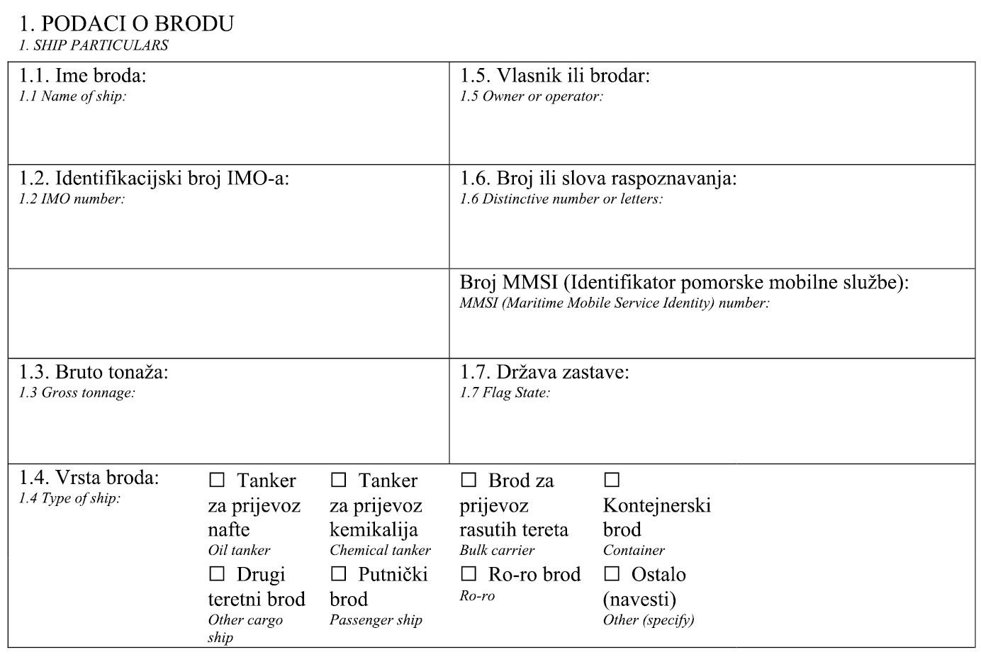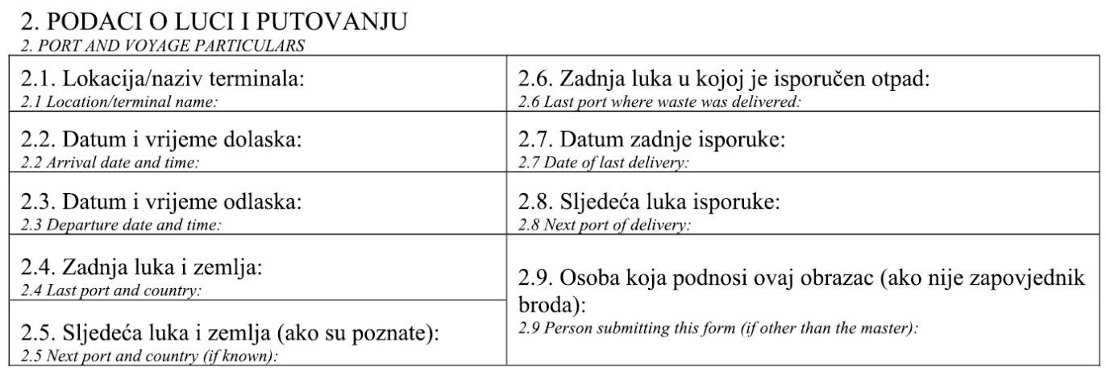

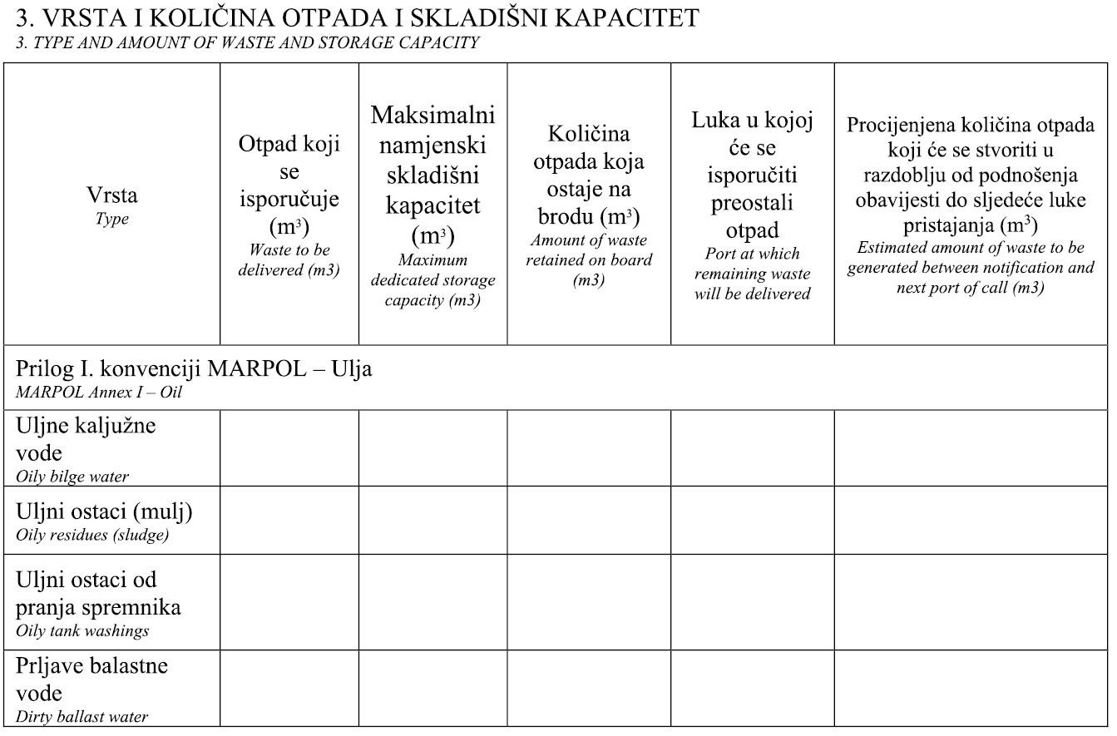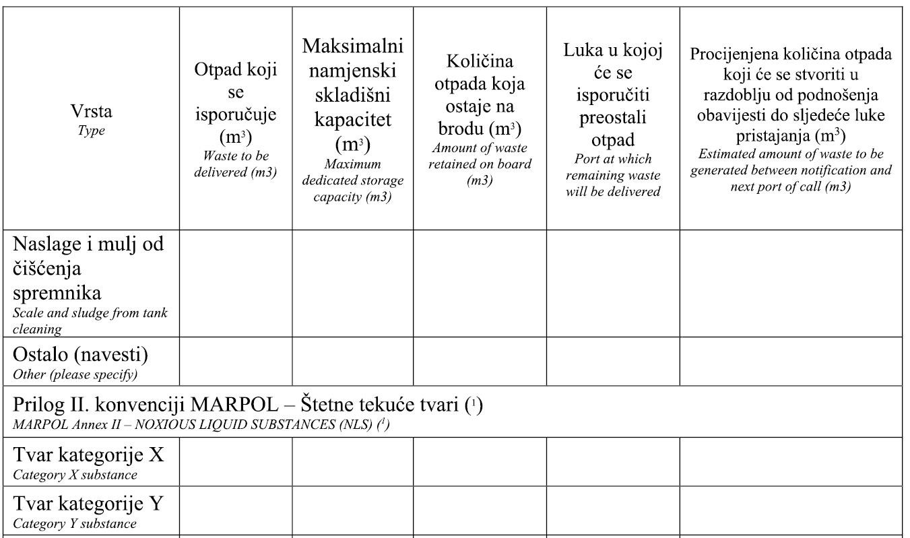

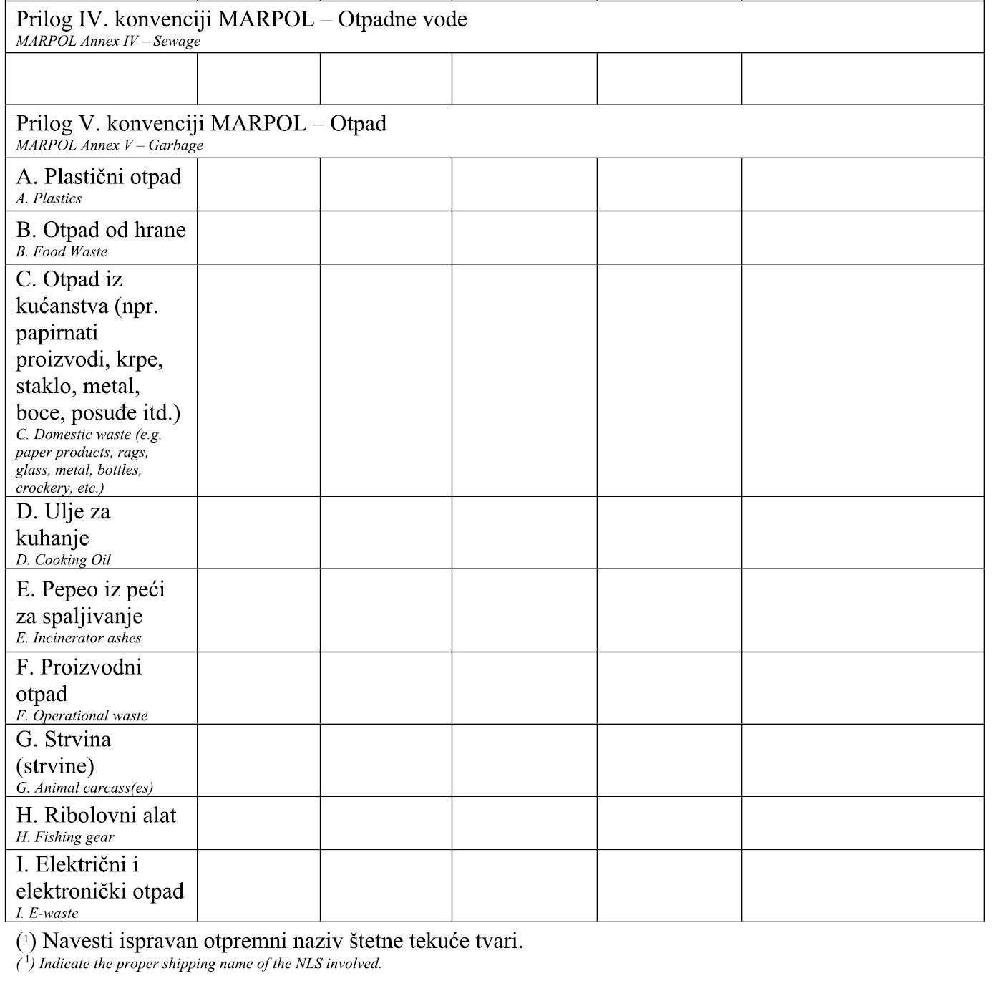

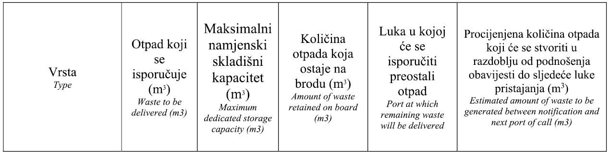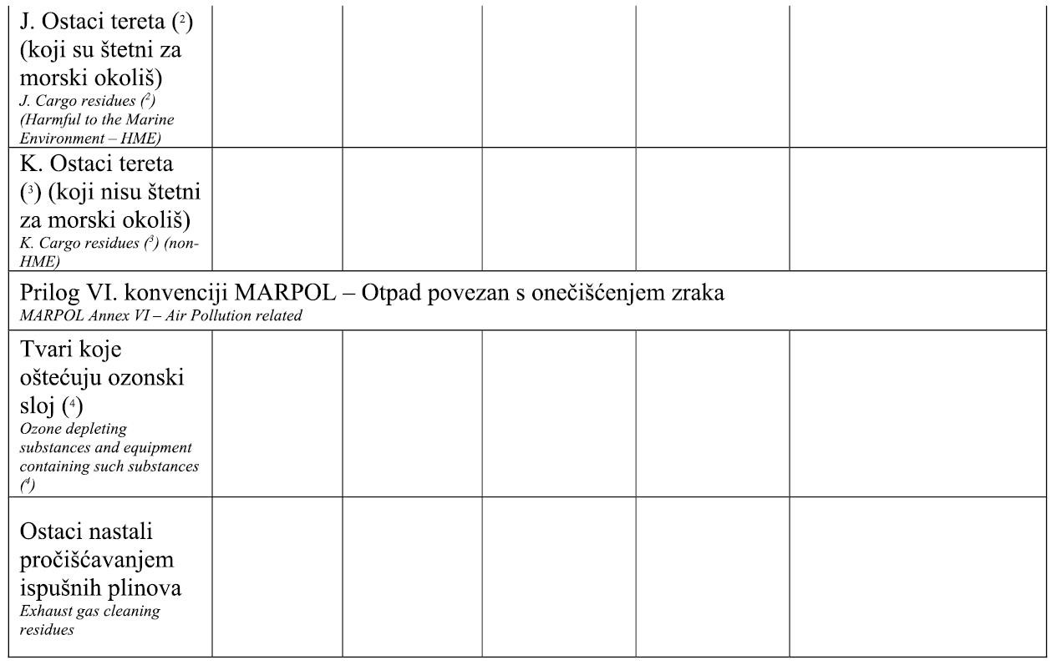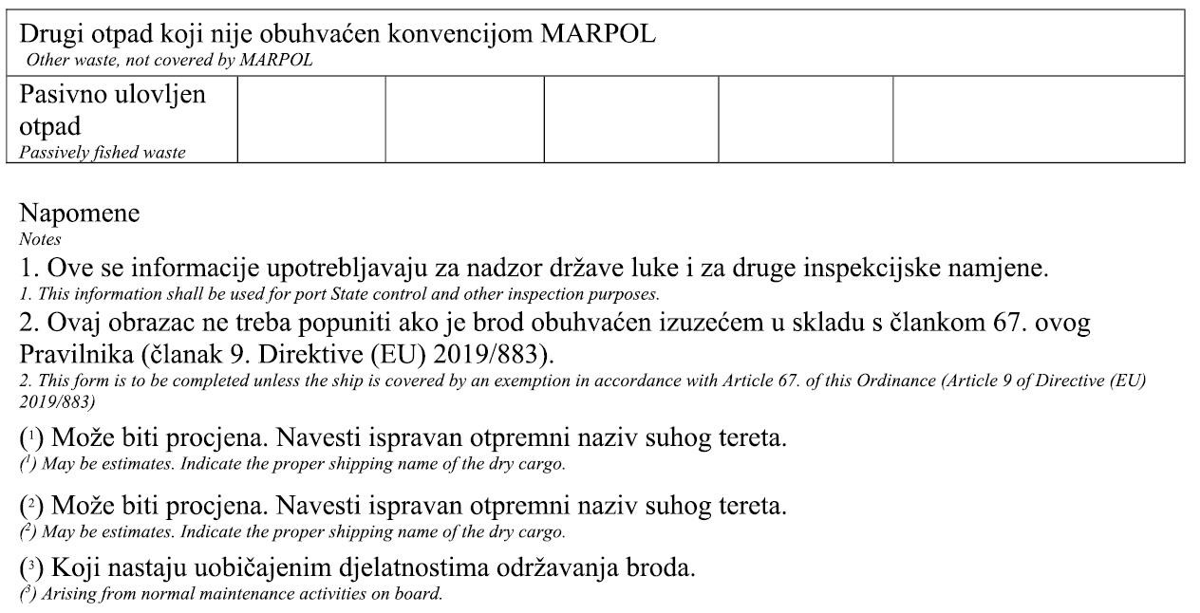

Form: Attached waste record confirmation – Annex II
Annex XII
ATTACHED WASTE RECORD CONFIRMATION FORM PL-O
SHIPMENT OF WASTE (A) | NUMBER PL-O
CODE | MUNICIPAL |  | OPERATIONAL | NOXIOUS | NON-NOXIOUS
DANGEROUS PROPERTIES HP1 HP2 HP3 HP4 HP5 HP6 HP7 HP8 HP9 HP10 HP11 HP12 HP13 HP14 HP15
PHYSICAL PROPERTIES powder solid paste sludge liquid gas other
PACKAGING WASTE bulk receptable drum canister container barrel box bag other PACKAGE NO.
DESCRIPTION
ORIGIN OF MUNICIPAL WASTE (to be filled in by service provider only )
SENDER(B)  COMPANY  OIB *  TRANSPORT AUTHORISATION  CONTACT PERSON  CONTACT DATA  *personal identification number |  | OWNER OF WASTE AT MOMENT OF COLLECTION  REPORT: YES NO  STARTING POINT  DESTINATION  AMOUNT m₃ WEIGHING ESTIMATION  TIME OF DELIVERY  DELIVERED BY
TRANSPORT OPERATER (C)  COMPANY  OIB  TRANSPORT AUTHORISATION  CONTACT PERSON  CONTACT DATA |  | MODE OF TRANSPORT road train sea air inland waterwas  REGISTRATION NUMBER  COLLECTED BY  TIME  DELIVERED BY
RECIPIENT (D)  COMPANY  OIB  TRANSPORT AUTHORISATION  CONTACT PERSON  CONTACT DATA |  | COLLECTED BY  WEIGHING TIME  AMOUNT COLLECTED
BROKER OR DEALER (E)  COMPANY  OIB  TRANSPORT AUTHORISATION  CONTACT PERSON  CONTACT DATA |  | TREATMENT OPERATOR (F)  COMPANY  OIB  TREATMENT AUTHORISATION  TREATMENT COMPLETION DATE  TREATMENT PROCEDURE  CONFIRMED BY
NOTES AND ANNEXES (H)

Annex III - Form: Waste delivery receipt
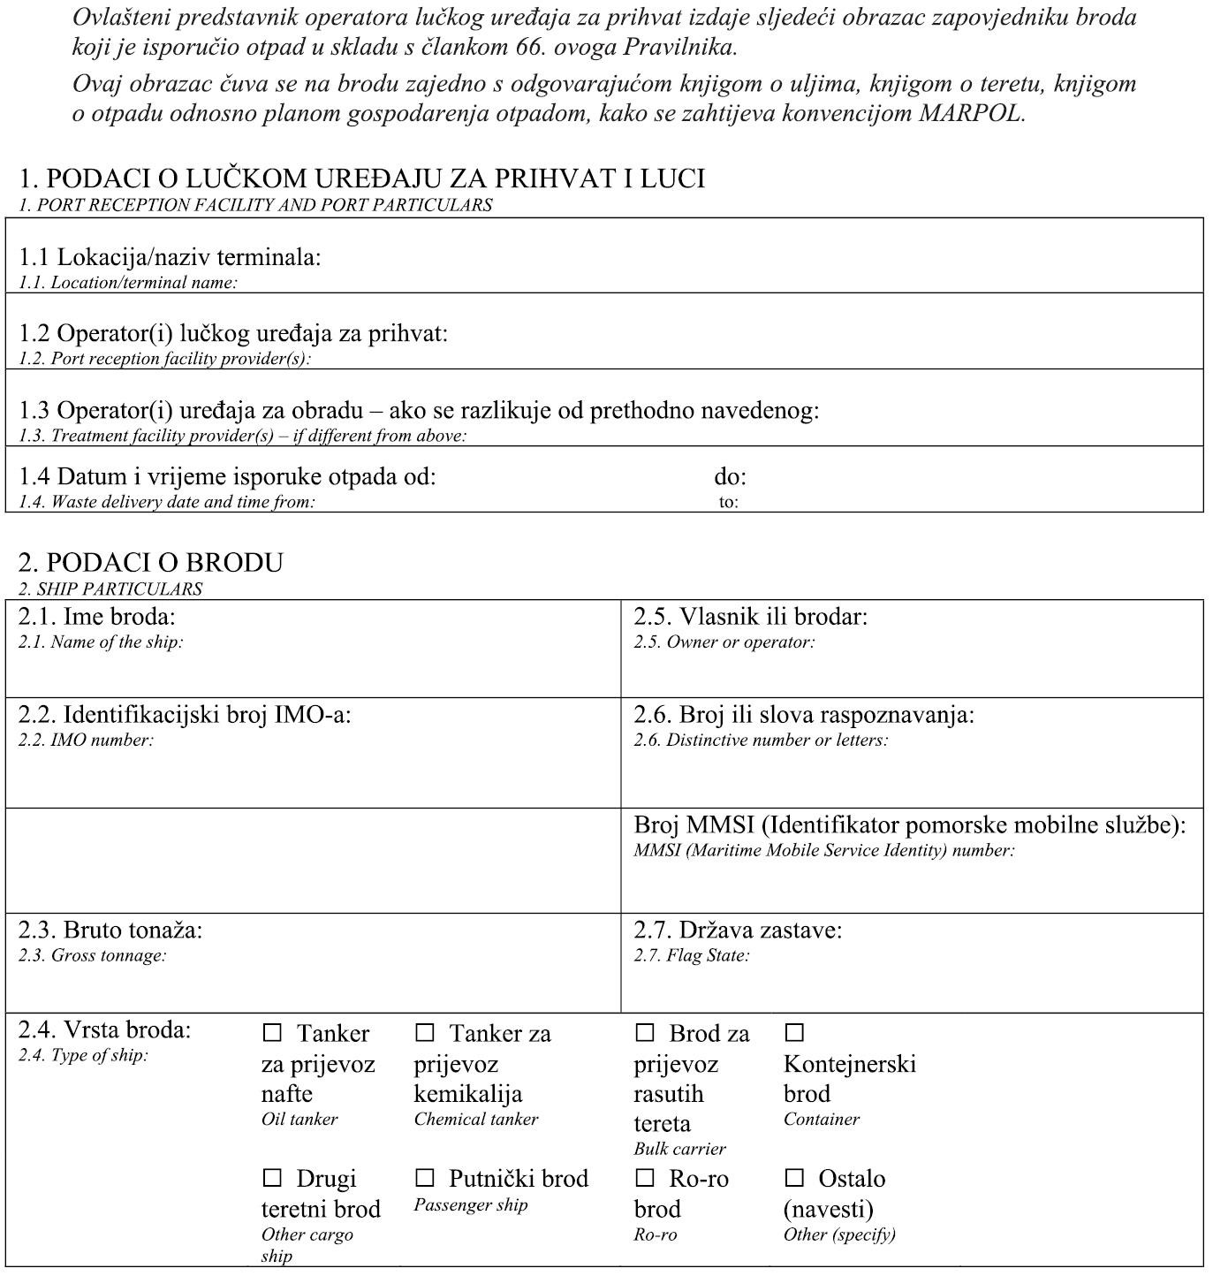

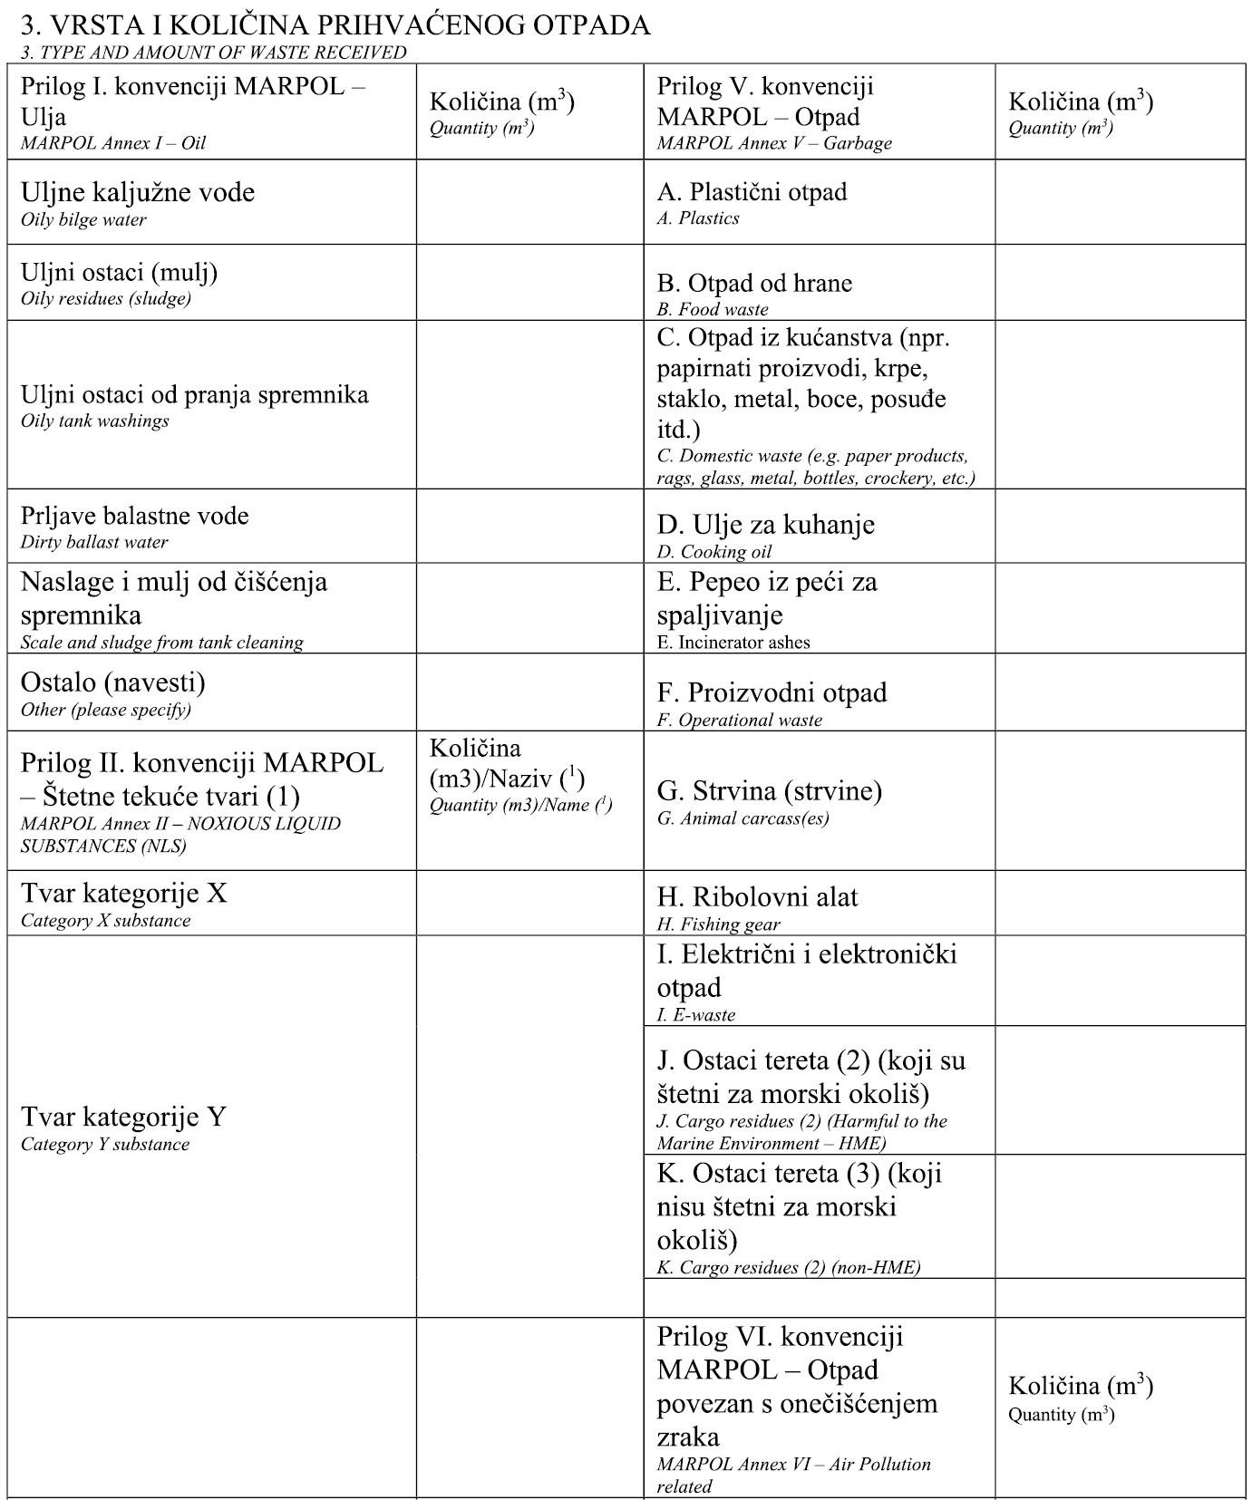

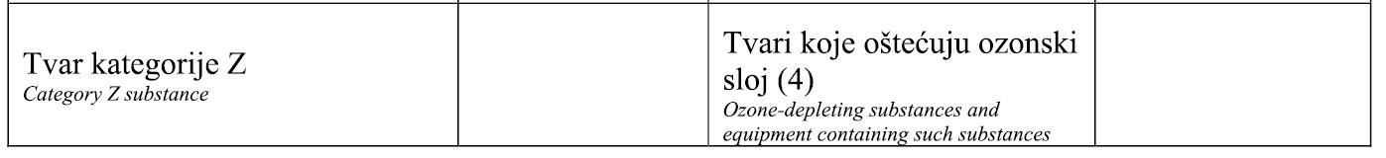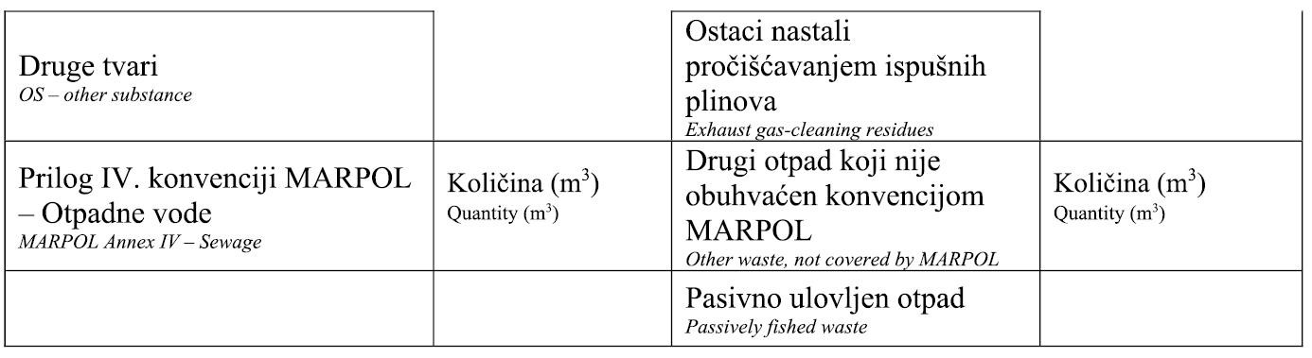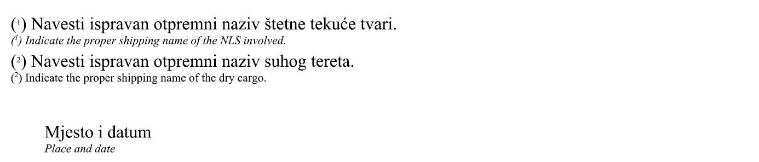

Annex IV -Form: Certificates of exemption

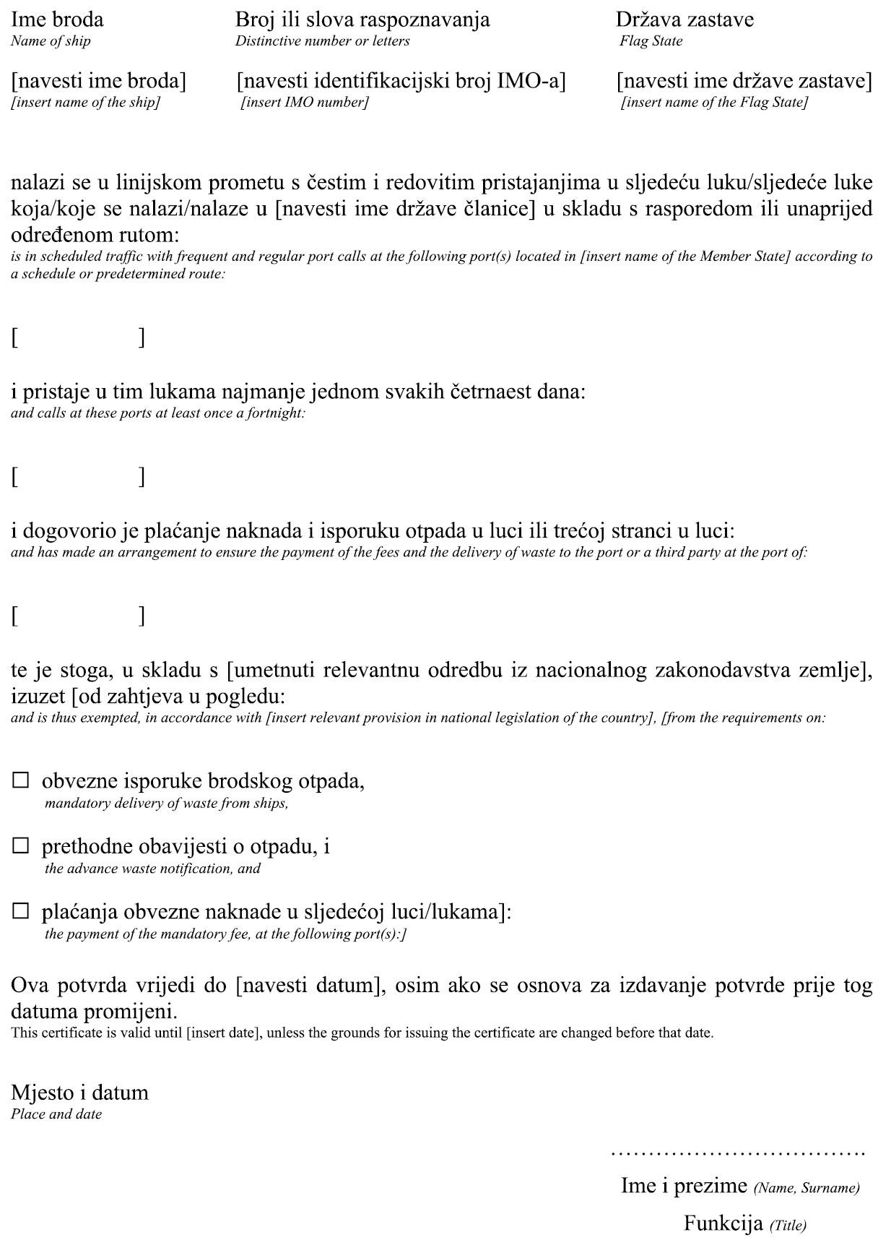

Annex V - Form for transport of animal by-products and derived products
COMMERCIAL DOCUMENT
Form for transport of animal by-products and derived products not intended for human consumption in European Union in accordance with Regulation (EC) No 1069/2009
Part I  Information on | I.1 | Sender  Name  Address  Postal code |  |  |  |  |  |  |  |  |  | I.2 Document reference number |  |  |  | I.2a Local reference number
 |  |  |  |  |  |  |  |  |  |  |  | I.3 Central authority
 |  |  |  |  |  |  |  |  |  |  |  | I.4 Local authority
 | I.5 | Sender  Name  Address  Postal code  Telephone |  |  |  |  |  |  |  |  |  | I.6
 |  |  |  |  |  |  |  |  |  |  |  | I.7
 | I.8 Country of origin |  |  | ISO code | I.9  Region of origin |  | Code |  |  | I.10Country of destination |  |  |  | ISO code | I.11  Region of destination |  | Code
 | I.12 | Place of origin  Facility ☐  Name  Address  Postal code |  |  | Approval number |  |  |  | I.13 |  | Place of destination  Facility ☐  Name  Address  Postal code |  |  |  |  | Other☐  Approval number
 | I.14 Place of loading |  |  |  |  |  |  |  | I.15 Date of dispatch
 | I.16 | Means of transport  airplane ☐ Ship ☐ Railway wagon ☐ Road vehicle ☐ Other ☐ Identification |  |  |  |  |  |  | I.17 |  | Transport operator  Name Approval number  Address  Postal code Member state
 | I.18 Description of goods |  |  |  |  | I.19 Goods code
 |  |  |  |  |  |  |  |  |  |  |  |  | I.20 Quantity
 | I.21 Product temperature  ambient ☐ chilled ☐ frozen ☐ controlled temperature ☐ |  |  |  |  |  |  |  |  |  |  |  | I.22 Package number
 | I.23 Seal/Container number |  |  |  |  |  |  |  |  |  |  |  | I.24 Packaging type
I.25 Certified goods for:
Animal food ☐ For technical use ☐
 | I.26 |  |  |  |  |  |  | I.27 Transit through Member states ☐  Member state ISO Code  Member state ISO Code  Member state ISO Code
 | I.28 |  | Export  Third country ISO Code  Exit point code |  |  |  |  | I.29
 | I.30
I.31 Identification of goods
Type Type of goods Category Type of treatment Approved series (batch)no.
(scientific name)

COUNTRY
Animal by-products and derived products not intended for human consumption
Part II Certifications | II Health information |  | II a Certificate reference number | II b
II.1 Declaration by supplier
I, the undersigned, hereby declare the following:
II.1.1. that the information in part I is accurate;
II. 1.2. that all necessary precautions have been taken in order to prevent contaamination of animal by-products or derived products pathogenic agents or cross-contamination in various categories.
Notes:
Part I
- Fields I.9 and I.11, if necessary
-Fields I.12, I.13 and I.17; approval number or registration number
-Field I.14; to be filled in if different from Field 'I.1 Sender'.
-Field 1.25:technical use: any use other than animal feeding
-Field: I.31
 | Animal type  Type of goods  Category  Manner of processing  Series(batch) number | For Category II materials and products derived from them intended for animal feed. Select between the following: birds, ruminants, non-ruminants, mammals, fish, molluscs, crustaceans, invertebrates  Enter unprocessed animal by-products or processed product from the following list: 'apiculture by-products', 'blood products, 'blood', 'blood meat', 'derived products' (except in the final item, in which case a commercial document is not required), 'digestion residues', 'digestive tract content', 'dog chews'(except in the final item, in which case a commercial document is not required), 'fishmeal', 'flavouring innards', 'gelatine', 'greaves','leather' (except in the final item, in which case a commercial document is not required), 'hydrolysed proteins', 'organic fertilizers','pet food', 'processed animal protein', 'processed pet food' (except in the final item, in which case a commercial document is not required), 'raw pet food', 'rendered fats', 'compost', 'processed manure', 'fish oil', 'dairy products', 'centrifuge or separator sludge from milk processing, 'dicalcium phosphate', 'tricalcium phosphate', 'collagen', 'egg products', 'serum from equidae', 'game trophies', 'wool' (except in the final item, in which case a commercial document is not required), 'hair', 'pig bristles', 'feathers', 'animal by-products to be processed'.  Categories 1, 2 and 3.  In case of Category 3 material, enter letters from a to p as set out in Article 10 of Regulation (EC) no. 1069/2009. In case of animal by-product to be used in raw pet food, enter 3a or 3b (i,ii or iii), that is, whether animal by-products are referred to in Article 10, Items b, or in point ii or Item n of Regulation (EC) 1069/2009.  In case of hides or leather products, enter 3b(ii) or 3n (i,ii or iii), that is, whether animal by-products are referred to in Article 10, Items a or b, or in point i or ii of Regulation (EC) 1069/2009. If the shipment contains materials from more than one category, enter quantity, and where necessary container number by material category.  For processed hides that (a) do not meet requirements of Regulation (EC) no. 863/2004 of European Parliament and Council of 29 April 2004, establishing specific rules on the hygiene of food of animal origin or (b) have not undergone the complete tanning process or (c), are not wet blue, or (d) haven't been pickled or (e) treated with lime with the ph of the pickling liquor being 12-13, lasting not less than eight hours):  To enter one of the following treatments:  - dried  - dry-salted or wet-salted  - salted for seven days in sea salt with the addition of 2% of natrium carbonate  For materials from Category 3 and products derived from them in order to be used for animal feed; where applicable, describe the processing type and method . Indicate the corresponding processing method ()select one of the methods referred to in Chapter III, Annex IV of Regulation (EC) no. 142/2011.  Enter series ( batch) number, ore ar mark, as applicable.  The signature shall be in a different colour to that of the printing.
Signature
Drawn up in _________________________on __________________
(place) (date)
Signature of the resposible person/sender

Annex VI - Records of waste water collection
 |  |  |  |  | ZOP-OV |  | 2022
Records of waste water collection
MARPOL Annex IV
Document no. | ___ /2022 |  |  | Date of removal
Amount: | __ m³ | ___/tons |  | Collection date
Arrival no. |  |  | Packaging no.
Place of origin/collection
Name of entity:
OIB (personal identification number)/BP(vessel number):
Headquarters address:
Contact person:
Contact information:
Transport operator
Name of entity:
OIB (personal identification number)/BP(vessel number):
Headquarters address:
Contact person:
Contact information:
Registration number:
Waste collection company
Name of entity:
OIB (personal identification number)/BP(vessel number):
Headquarters address:
Address of collection:
Contact person:
Contact information:
Notes:

Delivered by: Collected by:

Annex VII- Data on annual quantities and type of waste and costs of waste reception, collection and disposal
Annex I of MARPOL Convention - Oil | Annual amount | Costs per amount unit (kn/m³) | Costs of reception, collection and disposal of waste in past year
Oily bilge water
Oil residues (sludge)
Waste cargo hold washing oil residues
Dirty ballast water
Hold cleaning residue and sludge
Other (specify)
Annex II of MARPOL Convention – Noxious Liquid Substance
substance in category X – indicate the proper shipping name of noxious liquid substance
Substance in category Y – indicate the proper shipping name of noxious liquid substance
Substance in category Z-indicate the proper shipping name of noxious liquid substance
Other substances - indicate the proper shipping name of noxious liquid substance
Annex IV of MARPOL Convention
Waste water
Annex V of MARPOL Convention - Waste
A Plastic waste
B Food waste
C Domestic waste
D Cooking oil
E Incinerator ashes
F Operational waste
G Animal carcasses

Annex VIII - Plan of port area with locations of port waste reception facilities
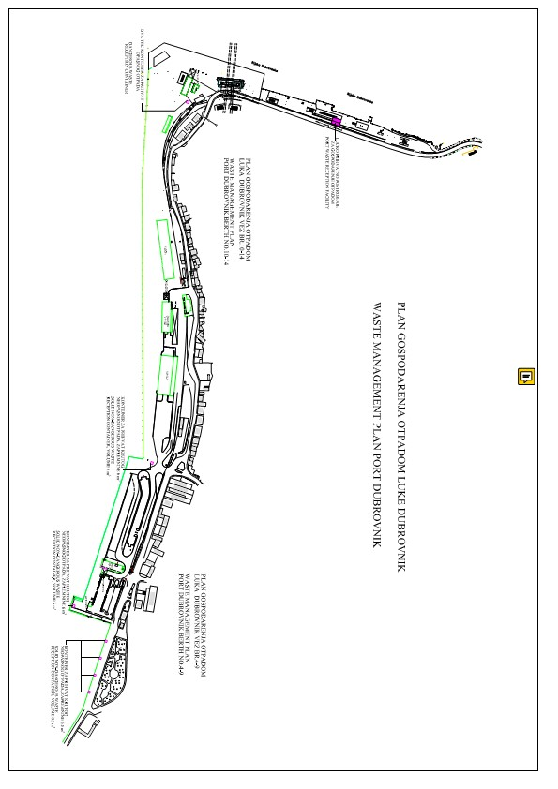

Annex IX - Inadequacy of Port Reception Facilities for ship waste
INADEQUACY OF PORT RECEPTION FACILITIES FOR SHIP WASTE
1 LOCATION OF THE PORT
Country name: | Port name:
Berth name:
Date of inadequacy:

2 TYPE AND AMOUNT OF WASTE COLLECTED IN PORT WASTE RECEPTION FACILITIES
WASTE TYPE | AMOUNT | WASTE TYPE | AMOUNT
Oil waste | m³ | Food waste | m³
Other liquid waste (specify) | m³ | Plastic waste | m³
Accumulated waste | m³ | Cargo residues | m³
Other | m³

3 DESCRIPTION OF INADEQUACY
Technical usablity of the PWRF | Delay
Inadequate location of PWRF | Other

NOTES

4 NOTES ON SHIP
Ship name: | IMO ship identification number:
Port of registry: | Nationality:
Ship owner or operator:

Form delivery date:
Ship's master: | Signature:
Port authority | Signature:
Annex X - Calculating overhead costs
Dubrovnik Port Authority direct operational costs

Concessionaire | Annual costs | Shared operational costs (%) | Shared operational costs (kn)
Luka Dubrovnik d.d. | 10.621.327,12 | 66.35700689 | 0,408658103
Cian d.o.o. | 4.582.405,73 | 28,62869442 | 0,176283888
Platanus d.o.o. | 802.605,62 | 5,014298691 | 0,030880499
Total costs | 16.006.338,46 | 100
Gross tonnage 2019 | 25.968.413,00
Direct operational costs/total gross tonnage 2019 | 0,62
Basis for calculating direct operational costs is total gross tonnage of all cruisers (cruiser-i) staying in Port of Gruž in 2019.

 | Overhead administrative costs
Port managing body
Dubrovnik Port Authority | 231.630,00
Gross tonnage 2029 | 25.968.413,00
Overhead administrative costs/total gross tonnage 2019 | 0,008919683

Indirect charges / direct operational costs / indirect administrative costs
Indirect charge 0,628919683 kn/gross tonnage of ship

