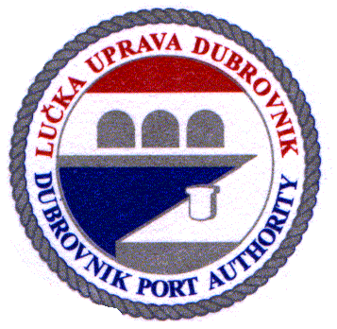 | Lučka uprava Dubrovnik / Dubrovnik Port Authority  Obala Pape Ivana Pavla II, br.1; 20000 Dubrovnik; Hrvatska / Croatia  tel. + 385 20 313-333, fax: + 385 20 418-551  e-mail: padubrovnik@portdubrovnik.hr  OTKAZ REZERVACIJE / RESERVATION CANCELLATION
Ime broda / Name of ship:

Država pripadnosti / Ship's flag:
Luka upisa / Port of registry:
IMO broj / IMO number:
Naziv i adresa brodara / Name and address of the company:
Duljina broda / Length of the ship (m):
Bruto tonaža (BT) / Gross tonnage (GT):
Gaz (m) / Drought (m):

rb | Najavljeni datum i vrijeme dolaska / Announced date & time of ship's arrival | Najavljeni datum i vrijeme odlaska / Announced date & time of ship's departure
1.
2.
3.
4.
5.
6.
7.
8.
9.
10.
11.
12.
13.
14.
15.

Brodski agent / Shipping agency:

Naziv / Name:
Adresa / Address:
Potpis i pečat / Sign and stamp:

Datum / Date: |  | ObrazacLU1006 / FormPA1006

