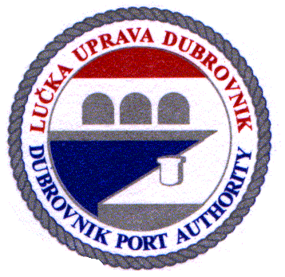 | Lučka uprava Dubrovnik / Dubrovnik Port Authority  Obala Pape Ivana Pavla II, br.1; 20000 Dubrovnik; Hrvatska / Croatia  tel. + 385 20 313-333, fax: + 385 20 418-551  e-mail: padubrovnik@portDUBROVNIK.hr  NAJAVA DOLASKA BRODA U LUKU / SHIP CALL ANNOUNCEMENT
Ime broda / Name of ship:

Država pripadnosti / Ship's flag:
Luka upisa / Port of registry:
IMO broj / IMO number:
Naziv i adresa brodara / Name and address of the company:
Duljina broda (m) / Length of the ship (m):
Bruto tonaža (BT) / Gross tonnage (GT):
Gaz (m) / Drought (m):
Kapacitet putnika / Max number of passengers:
Broj članova posade / Number crew members:

rb | Datum i vrijeme dolaska / Date & time of ship's arrival | Datum i vrijeme odlaska / Date & time of ship's departure | Prethodna luka / Last port of call | Sljedeća luka / Next port of call
1.
2.
3.
4.
5.
6.
7.
8.
9.
10.
11.
12.
13.
14.
15.

Brodski agent / Shipping agency:

Naziv / Name:
Adresa / Address:
Potpis i pečat / Sign and stamp:

Datum / Date: |  | ObrazacLU1005 / FormPA1005

