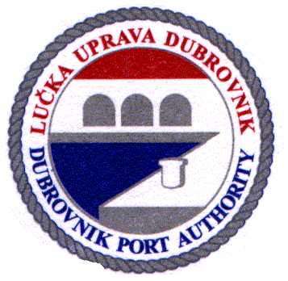 | Lučka uprava Dubrovnik / Port Authority of Dubrovnik  Obala Pape Ivana Pavla II, br.1; 20000–Dubrovnik; Hrvatska/Croatia  tel. + 385 20 313-333, fax: + 385 20 418-551  e-mail: padubrovnik@portdubrovnik.hr  IZVJEŠTAJ O BORAVKU BRODA U LUCI DUBROVNIK /  SHIP RECORD DURING PORT STAY IN DUBROVNIK
Ime broda / Name of ship:

Država pripadnosti / Ship's flag:
Luka upisa / Port of registry:
IMO broj / IMO number:
Naziv i adresa brodara/Name and address of the company:
Duljina broda / Length of the ship (m):
Bruto tonaža (BT) / Gross tonnage (GT):
Datum i vrijeme dolaska / Date & time of ship’s arrival:
Datum i vrijeme odlaska / Date & time of ship’s departure:
Ime prethodne luke / Last port of call:
Ime sljedeće luke / Next port of call:
Broj veza ili Gruž sidro / Berth number or Gruž anchorage:
Broj putnika na dolasku / Passengers no. on arrival:
Broj putnika iskrcanih / No. of passengers disembarked:
Broj putnika ukrcanih / No. of passengers embarked:
Broj putnika u tranzitu / No. of passengers in transit:
Broj posade na dolasku / No. of crew on arrival:
Broj posade iskrcanih / No. of crew disembarked:
Broj posade ukrcanih / No. of crew embarked:

Aktivnosti vezane za boravak broda u luci / Ship's activities during port stay

(upisati križić / mark with cross):
Bojanje brodske oplate /  Painting of the ship’s hull: | Yes | No
Vježbe na brodu /  Ship's drill: | Spuštanje brodica /  Lowering lifeboat | Prijetnja bombom  / Bomb threat | Protupožarna zaštita / Fire | Polucija /  Oil spill | Sumnjivi predmet /  Suspicious device
Opskrba broda / Ship's supply: | Voda / Water  Quantity:__________ | Hrana/Provisions | Gorivo/Bunker  Quantity:________ | Brodski dijelovi / Ship's parts
Odlaganje otpada /  Garbage disposal: | Yes | No | Specified quantity:
Otpadne tekućine / Liquid waste: | Yes | No | Quantity:
Podvodni pregled brodskog trupa/ Underwater inspection of ship's hull: | Yes | No | Posada broda /  Ship's crew | Domaća tvrtka / Shore company
Ostalo / Other:
.

Brodski agent / Shipping agency:
Naziv / Name:

Adresa / Address:
Potpis i pečat/Sign & stamp:

Napomena/Note: Obrazac dostaviti najkasnije 24 sata nakon odlaska broda iz luke/Form to be delivered not later than 24 hours after ship's departure.

Obrazac dostaviti i u slučaju otkaza rezervacije veza ili sidra / Form to be delivered even in case of cancelation of berth or anchorage.
Datum /Date: |  | ObrazacLU1004/FormPA1004
Brodski agent odgovara za točnost svih podataka dostavljenih ovim dokumentom. Podaci će se koristiti za formiranje dokumenata u vezi boravka broda u luci koji je predmet ovog izvještaja. Lučka uprava Dubrovnik ima pravo provjere točnosti podataka. / Ship’s agent is responsible for the accuracy of all information submitted in this document. The data will be used for creating documents related to ship stay at the port which is the subject of this report. Dubrovnik Port Authority has the right to verify the accuracy of information.

